Title: **BCD and Logic Diagrams** Test: 5

Course: Introduction to Automation Unit: Introduction to PLC CLO: 4

Name ____________________________ Date ______________

**Objectives**

1. Student shall calculate the correct number conversion base on a number from a different number base system.
2. Student shall draw the output of an instruction given its input(s).

**Assessment**

Students shall demonstrate a comprehension of the objectives listed above by scoring a minimum of 75% on this Test. Grading shall be based on the answer key.

**Instructions**

Calculate the following number to the new number base system given the value from another number base system.

|  |  |  |  |  |  |  |  |  |  |  |  |  |  |  |  |  |  |  |  |  |  |  |  |  |  |  |  |  |  |  |  |  |  |  |  |  |  |  |  |  |  |  |  |  |  |  |  |  |  |  |  |  |  |  |  |  |  |  |  |  |  |  |  |  |  |  |  |  |  |  |  |  |  |  |  |  |  |  |  |  |  |  |  |  |  |  |  |  |  |  |  |
| --- | --- | --- | --- | --- | --- | --- | --- | --- | --- | --- | --- | --- | --- | --- | --- | --- | --- | --- | --- | --- | --- | --- | --- | --- | --- | --- | --- | --- | --- | --- | --- | --- | --- | --- | --- | --- | --- | --- | --- | --- | --- | --- | --- | --- | --- | --- | --- | --- | --- | --- | --- | --- | --- | --- | --- | --- | --- | --- | --- | --- | --- | --- | --- | --- | --- | --- | --- | --- | --- | --- | --- | --- | --- | --- | --- | --- | --- | --- | --- | --- | --- | --- | --- | --- | --- | --- | --- | --- | --- | --- | --- |
| 1. 123410 ______ ______ ______ ______BCD | |  |  |  |  |  | | --- | --- | --- | --- | --- | | BCD Truth Table | | | | | |  |  |  |  |  | |  |  |  |  |  | |  |  |  |  |  | |  |  |  |  |  | |  |  |  |  |  | |  |  |  |  |  | |  |  |  |  |  | |  |  |  |  |  | |  |  |  |  |  | |  |  |  |  |  | |  |  |  |  |  | |  |  |  |  |  | |  |  |  |  |  | |  |  |  |  |  | |  |  |  |  |  | |  |  |  |  |  | |  |  |  |  |  | |
| 1. 561210 ______ ______ ______ ______BCD |
| 1. 220110 ______ ______ ______ ______BCD |
| 1. 629810 ______ ______ ______ ______BCD |
| 1. 473610 ______ ______ ______ ______BCD |
| 1. 679110 ______ ______ ______ ______BCD |
| 1. 0101 1001 0011 1000BCD __________10 |
| 1. 1001 0100 1001 0111 BCD __________10 |
| 1. 0111 1000 1001 0110 BCD __________10 |
| 1. 0100 1011 0001 0000 BCD __________10 | |
| 1. 0000 0001 0010 0111 BCD __________10 | |
| 1. 1000 0011 1001 0110 BCD __________10 | |

Convert the following to the indicated number base.



1. Word _____16
2. Byte _____BCD
3. Bit _____10
4. Nibble _____8
5. Does this rung have logical continuity? Why or why not? Explain in detail.

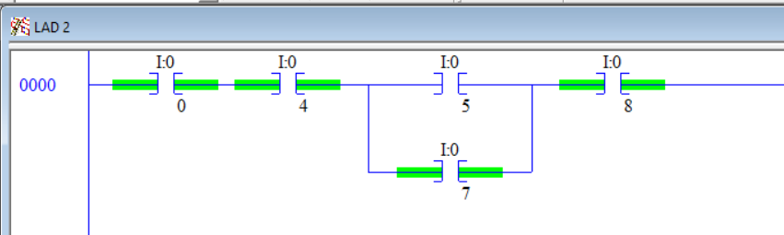

Select the best answer to each multiple-choice question below.

1. An EQU would be used to?
   1. Test two numbers to see if they are the same
   2. Set one number equal to another number
   3. Write a word to an integer
   4. All of the above
2. A GEQ would be used to?
   1. Make sure a number is less than a specific value
   2. Test for a number to be at least a given number
   3. Test two number to see if they are not equal
   4. None of the above
3. A OSF would be used to?
   1. Check to see if a value is ON
   2. Force an output value
   3. Indicate that a value went to 0 this scan
   4. Set if a number has been FALSE
4. A OTU would be used to?
   1. Clear a bit value
   2. Turn on a pilot light
   3. Counting up to a certain Preset then setting the done bit
   4. Is used to test for a 0
5. Fill in the state of each counter bit (0 or 1).

|  |  |
| --- | --- |
|  | CU _____  DN _____ |

1. How does a number become negative inside the PLC?
   1. The first bit indicates the sign
   2. The MSB equaling 1
   3. All the bits are 1
   4. None of the above

Draw the output to the following logic diagrams.





Draw the output to the following logic diagrams.



